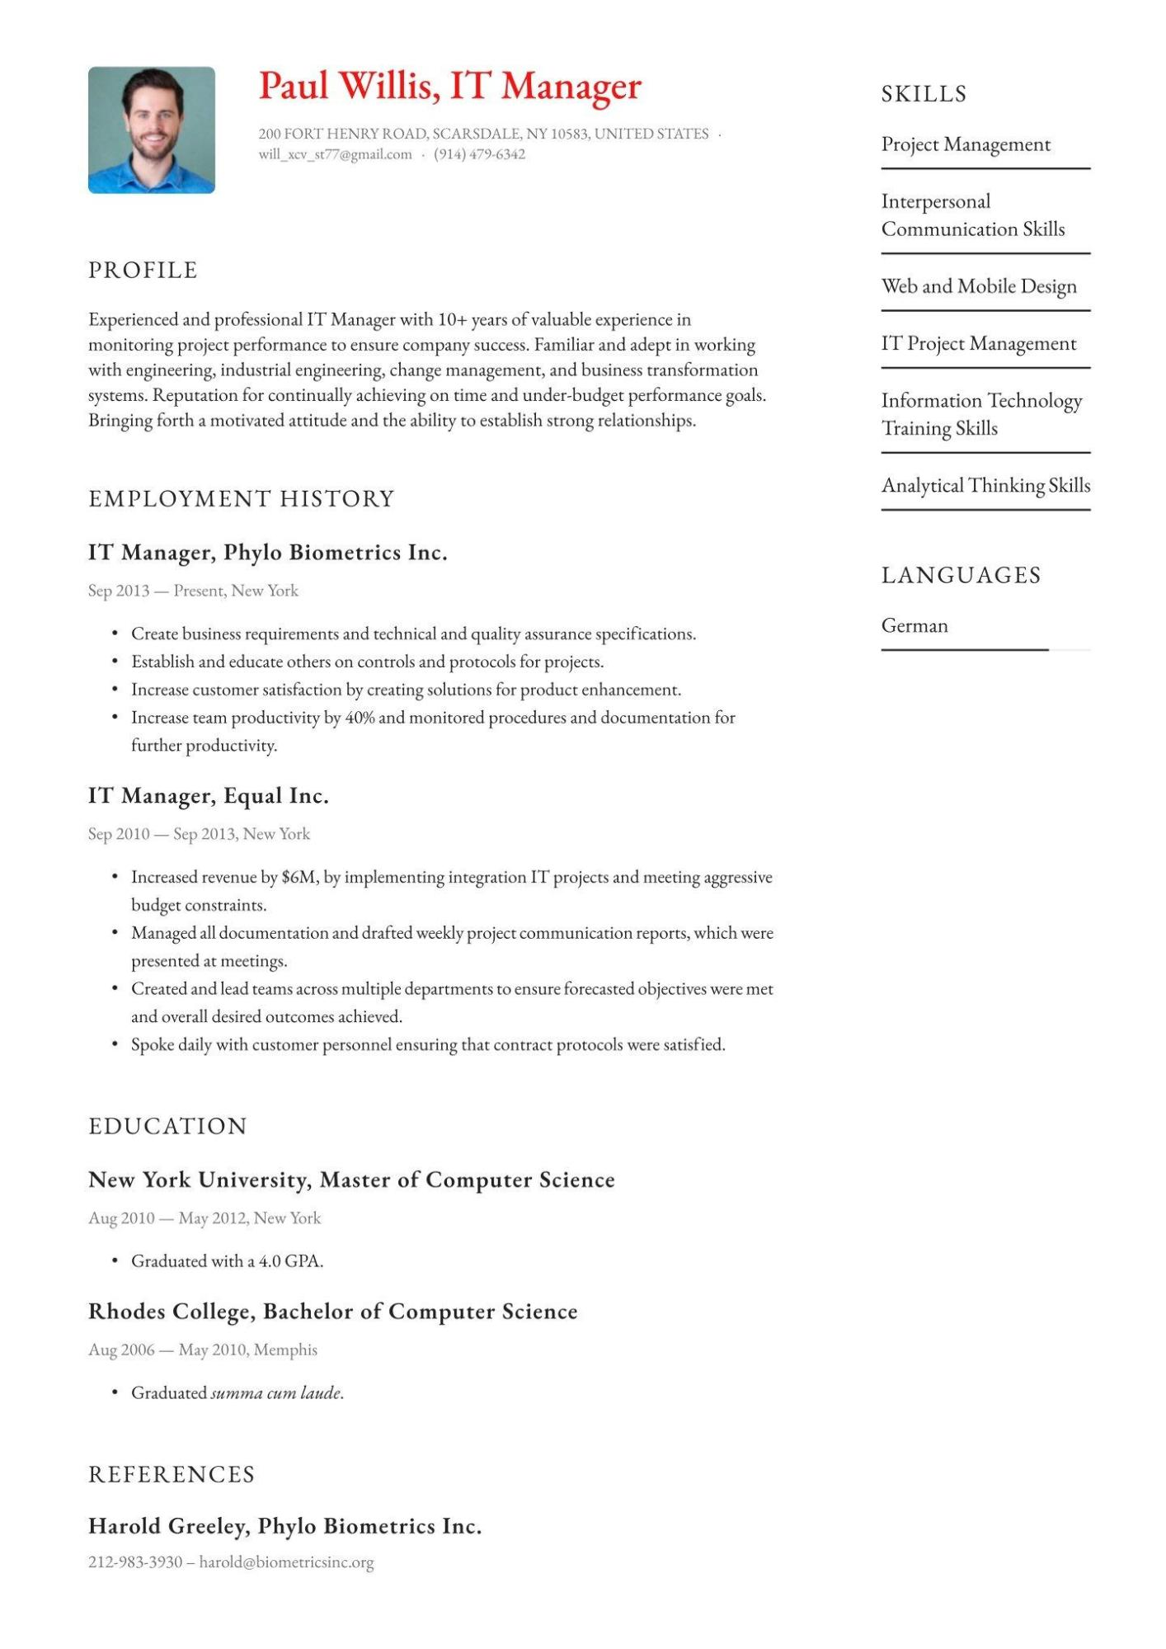
Paul Willis, IT Manager
200 FORT HENRY ROAD, SCARSDALE, NY 10583, UNITED STATES. will_xcv_st77@gmail.com
(914) 479-6342
PROFILE
Experienced and professional IT Manager with 10+
years
of valuable experience in
monitoring project performance to ensure company success. Familiar and adept in working with engineering, industrial engineering, change management, and business transformation systems. Reputation for continually achieving on time and under-budget performance goals. Bringing forth a motivated attitude and the ability to establish strong relationships.
SKILLS
Project Management
Interpersonal
Communication Skills
Web and Mobile Design
IT Project Management
Information Technology Training Skills
Analytical Thinking Skills
EMPLOYMENT HISTORY
IT Manager, Phylo Biometrics Inc.
Sep 2013-Present, New York
•
Create business requirements and technical and quality assurance specifications. Establish and educate others on controls and protocols for projects.
• Increase customer satisfaction by creating solutions for product enhancement.
• Increase team productivity by 40% and monitored procedures and documentation for further productivity.
IT Manager, Equal Inc.
Sep 2010- Sep 2013, New York
• Increased revenue by $6M, by implementing integration IT projects and meeting aggressive budget constraints.
•
•
Managed all documentation and drafted weekly project communication reports, which were presented at meetings.
Created and lead teams across multiple departments to ensure forecasted objectives were met and overall desired outcomes achieved.
Spoke daily with customer personnel ensuring that contract protocols were satisfied.
EDUCATION
New York University, Master of Computer Science
Aug 2010 May 2012, New York
• Graduated with a 4.0 GPA.
Rhodes College, Bachelor of Computer Science
Aug 2006- May 2010, Memphis
Graduated summa cum laude.
REFERENCES
Harold Greeley, Phylo Biometrics Inc.
212-983-3930- harold@biometricsinc.org
LANGUAGES
German

